CS 223

SECTION 3

BERAT BİÇER

21503050

24.10.2016

BOX 7

2-BIT ADDER SCHEMATIC

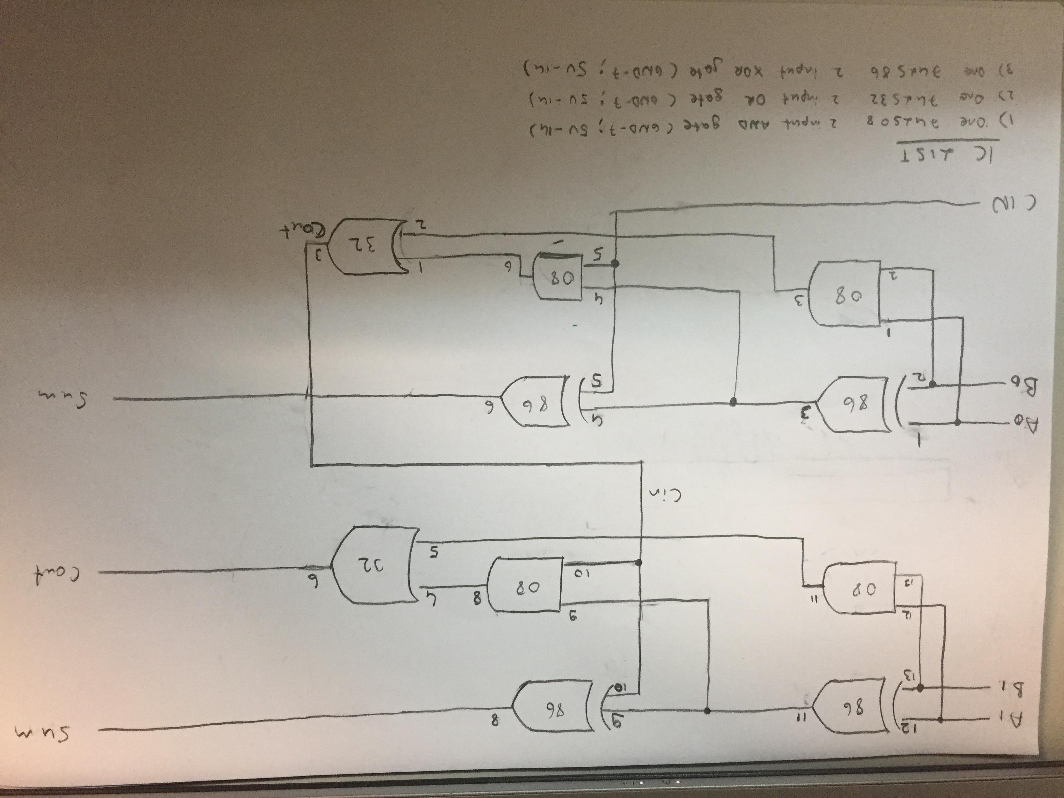

VERILOG MODULE & TESTBENCH FOR A FULL-ADDER

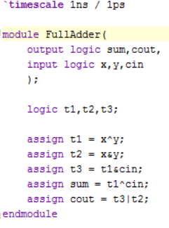

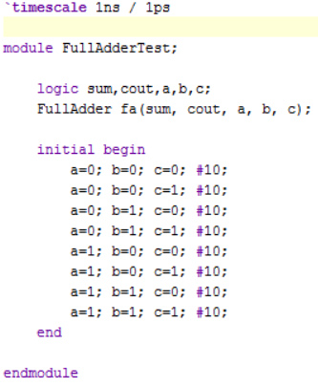

VERILOG MODULE & TESTBENCH FOR A TWO BIT ADDER

Code:

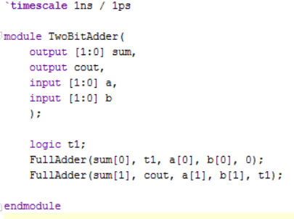

Test Bench:

